SIGHTSEEING DETAILS
Location : Paris, France
Duration : 90 minutes (Approx)

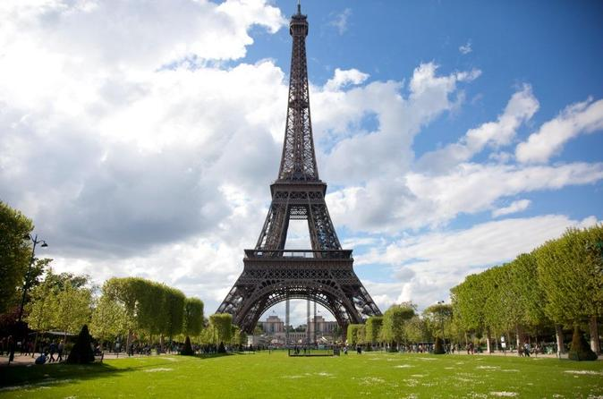
SKIP THE LINE: EIFFEL TOWER SMALL-GROUP TOUR
SIGHTSEEING OVERVIEW
Beat the queues at one of the world’s most famous attractions on this 1.5-hour, skip-the-line Eiffel Tower tour. Follow your guide through the Trocadero gardens to the base of the Eiffel Tower, where you'll learn of its changing fortunes, and marvel at the intricate ironwork up close

. Then, with your skip-the-line ticket, head straight up to the second floor for panoramic views over Paris. Enjoy personal attention from your guide on this small-group tour, limited to 20 people
Meet your guide near the Trocádero in central Paris in the morning or afternoon (depending on option chosen) then set off on foot past the fountains and sculptures of the Trocádero Gardens, toward the Eiffel Tower.
Cross the Seine River via the Iéna Bridge and listen as your guide sheds light on the Eiffel Tower’s rich 120-year history. Built by engineer Alexandre Gustave Eiffel as an entranceway to the 1889 World Trade Fair, the tower was initially slammed by critics as a blot on the landscape. Today, it takes pride of place among the most famous attractions in the world, drawing millions of visitors each year.
As you wander around the tower’s mighty feet with your guide, admire the impressive engineering at play and gain insight into its strength and durability. Afterward, enjoy skip-the-line access straight to the observation deck on the second floor and watch as your guide points out top Paris attractions including the Arc de Triomphe, Notre Dame Cathedral and the Sacré-Coeur Basilica.
When you’re ready to head back to terra firma, travel back down to ground level.
ADDITIONAL INFORMATION
Confirmation will be received at time of booking,
Extra measures may be implemented at some venues due to heightened global security. As a result, we may experience delays in getting through mandatory security checks when entering these venues. Extra measures may also restrict the size of bags that can be brought inside. To avoid disruptions or possible denied entry, we strongly suggest that you avoid bringing large purses, bags, or backpacks on your tour.,
It is the responsibility of all visitors to be at the meeting point 15 minutes before departure. Guests arriving after departure cannot be accommodated, & missed tours or tickets cannot be refunded.,
This tour involves a reasonable amount of walking; comfortable shoes are recommended,
Not trolley accessible,
Not wheelchair accessible,
Please note that it is NOT possible to buy a ticket for
the submit on the second floor of the Eiffel Tower.

INCLUSION
Reservation and entrance tickets with skip-the-line access to the 2nd floor of Eiffel Tower, Headsets when appropriate
EXCLUSION
Hotel pickup and drop-off, Gratuities (optional), Food and drinks
Grade Departure Time | Grade Title | Grade Description
10:00 AM | Eiffel Tower Tour at 10am | Skip the Line: Eiffel Tower Tour. Tour departs at 10am. Arrive strictly at 9:45am
12:00 PM | Eiffel Tower Tour at 12:00pm | Skip the Line: Eiffel Tower Tour. Tour departs at 12:00pm. Arrive strictly at 11:45pm
12:30 PM | Eiffel Tower Tour at 12:30pm | Skip the Line: Eiffel Tower Tour. Tour departs at 12:30pm. Arrive strictly at 12:15pm
1:30 PM | Eiffel Tower Tour at 1:30pm | Skip the Line: Eiffel Tower Tour. Tour departs at 1:30pm. Arrive strictly at 1:15pm
2:00 PM | Eiffel Tower Tour at 2pm | Skip the Line: Eiffel Tower Tour. Tour departs at 2pm. Arrive strictly at 1:45pm
4:30 PM | Eiffel Tower Tour at 4:30pm | Skip the Line: Eiffel Tower Tour. Tour departs at 4:30pm. Arrive strictly at 4:15pm
4:00 PM | Eiffel Tower Tour at 4pm | Skip the Line: Eiffel Tower Tour. Tour departs at 4pm. Arrive strictly at 3:45Pm
2:30 PM | Eiffel Tower Tour at 2:30 pm | Skip the Line: Eiffel Tower Tour. Tour departs at 2:30pm. Arrive strictly at 2:15pm
8:00 PM | Eiffel Tower at 8pm | Skip the Line: Eiffel Tower Tour. Tour departs at 8:00pm. Arrive strictly at 7:45pm
9:45 PM | Eiffel Tower at 9:45pm | Skip the Line: Eiffel Tower Tour. Tour departs at 9:45pm. Arrive strictly at 9:30pm
9:00 PM | Eiffel Tower at 9:00pm | Skip the Line: Eiffel Tower Tour. Tour departs at 9:00pm. Arrive strictly at 8:45pm
DEPARTURE INFORMATION
Departure Time : Varies
DeparturePoint : Near Trocádero, central Paris
DepartureTimeComments :
RETURN DETAILS
Concludes on the 2nd floor of the Eiffel Tower

SEINE RIVER HOP-ON HOP-OFF SIGHTSEEING CRUISE IN PARIS
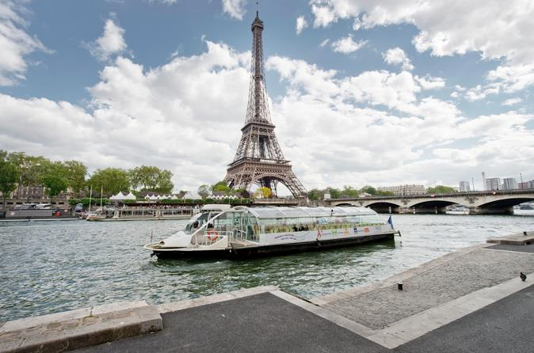
Location : Paris, France
Duration : Flexible
SIGHTSEEING OVERVIEW

Cruise along Paris’ Seine River on a hop-on hop-off sightseeing cruise! Use a 1-day ticket (24H) to travel to top Paris attractions such as the Eiffel Tower and the Louvre Museum, or upgrade to a 2-days (48H) ticket for another consecutive day of sightseeing. Simply hop on and off as many times as you like at any of the eight stops along the Seine River’s UNESCO-listed riverbanks.
A city that boasts more monuments than many other cities put together, Paris is a world-class sightseeing destination. Standout architecture, museums, art galleries and historic cathedrals line the UNESCO-listed banks of its famous Seine River, so what better way to see them than by a hop-on hop-off sightseeing cruise? Choose from a 1- or 2-day pass (24H and 48H), and then discover sightseeing opportunities galore on your hop-on hop-off Seine River cruise.
Aboard a panoramic riverboat, with both deck and lower-deck seating, admire top city attractions, such as Notre Dame Cathedral with its gorgeous French Gothic architecture, and Hôtel de Ville where the Mayor of Paris holds office.
Pass the chic neighborhood of Saint-Germain-des-Prés with its bustling boutiques and prestigious art galleries, and perhaps hop off at the Eiffel Tower to marvel at one of the world’s most iconic feats of architecture. Your route also allows you to hop off at the famous Louvre Museum as well as Musée d'Orsay, with its unparalleled collection of Renaissance art.
With your ticket, you can remain on the boat for an entire loop (roughly 1.5 to 2 hours) or you can hop on and off at any of the eight stops along the Seine River to explore Paris’ countless delights.

Seine River Hop-On Hop-Off Cruise Stops:
- Eiffel Tower
- Musée d'Orsay
- Saint-Germain-des-Prés
- Notre Dame Cathedral
- Jardin des Plantes
- Hôtel de Ville
- Louvre Museum (between Pont Royal and Pont du Carrousel)
- Champs Elysées

Please note: During times when the river levels are exceptionally high, certain stops may be closed and alternative routes provided.
ADDITIONAL INFORMATION
Confirmation will be received at time of booking,
Please check seasonal departure time
INCLUSION
Hop-on hop-off cruise
EXCLUSION
Commentary, Entrance fees, Gratuities (optional), Food and drinks, Hotel pickup and drop-off
Grade Departure Time | Grade Title | Grade Description
 | 1-Day Pass | Unlimited use of the Seine River hop-on hop-off cruise for one day
 | 2-Day Pass | Unlimited use of the Seine River hop-on hop-off cruise for two consecutive days
DEPARTURE INFORMATION
Departure Time : From January 4th until March 31th: Monday to Thursday: 10am - 5pm, every 40 minutes; Friday to Sunday: 10am - 7pm, every 40 minutes From April 1st until April 27th : 10am - 7pm, every 30 minutes, everyday From April 28th until September 3rd : 10am - 9:30pm, every 25 minutes, everyday From September 4th until November 5th : Monday to Thursday: 10am - 7pm, every 30 minutes From November 6th until December 24th : Monday to Thursday: 10am - 5pm, every 40 minutes; Friday to Sunday: 10am - 7pm, every 40 minutes From December 25th until January 7th : Everyday: 10am - 7pm, every 40 minutes From January 8th until March 29th : Monday to Thursday: 10 am to 5pm, every 40 minutes; Friday to Sunday: 10am to 7pm, every 40 minutes Please note that exchanges points will be closing at 6:00pm on December, 24th and 31th.
DeparturePoint : Board your boat and exchange your voucher (print-out or e-voucher) at any of the eight stops (at the ticket office) along the Seine River
DepartureTimeComments :

SKIP THE LINE: LOUVRE MUSEUM AUDIO TOUR

Location : Paris, France
Duration : Flexible
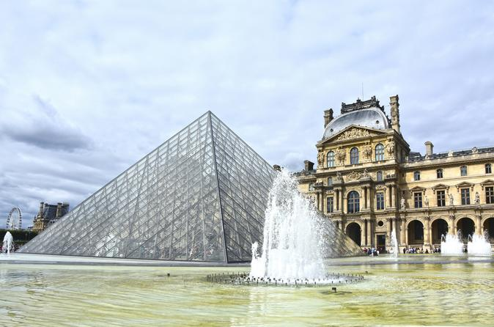
SIGHTSEEING OVERVIEW
Skip the long entrance lines at Paris' Louvre Museum and enjoy an audio tour of its many legendary works of art including the ‘Mona Lisa’ and ‘Venus de Milo.’ With more than 35,000 pieces on display, the Louvre can overwhelm even the most avid art lover, but this package provides you with an in-depth audio guide and a detailed museum map to help you design your own itinerary and navigate with ease. After concluding your 2.5-hour audio tour, continue exploring on your own, grab a bite to eat, or shop for souvenirs at the world’s most-visited museum.
Once you have collected your museum map and audio guide in a choice of nine languages, head to the Louvre and skip the long entrance lines to start your tour. The Louvre is one of the world’s largest museums, but don’t be intimidated – your handy map provides suggested routes to help you plan your visit, and your educational audio guide allows you to enjoy a more meaningful museum experience.
As you make your way through the museum, listen to commentary about the fascinating history and significance of the many artistic masterpieces you encounter, from the iconic Greek statue Venus de Milo to the staggeringly large painting of The Coronation of Napoleon to Leonardo da Vinci’s famously enigmaticMona Lisa. Admire sculptures by Michelangelo and paintings by Raphael, Rubens and Rembrandt. View the Babylonian Code of Hammurabi and other ancient artifacts. There’s so much to see!
Your audio guide provides a summary of some of the most popular and most famous exhibits at the Louvre, but there is still plenty more to see. When you have finished with the audio guide, wander the museum at your leisure, have a snack at one of the museum’s many eateries, or browse the selection of publications and artworks at the bookstores before returning your audio guide to the place you collected it from, before 8pm
ADDITIONAL INFORMATION
Confirmation will be received at time of booking,
A moderate amount of walking is involved,
A deposit of 32 Euros is required for each audio guide. This will be refunded when you return the audio guide at the end of the tour (before 8pm). 30 Euros from April, 1st 2018 until October, 31st 2018.,
The audio guide lasts 2.5 hours but you can stay in the museum and explore independently
INCLUSION
Fastpass admission ticket to the Louvre museum, Audio guide, Museum map with suggested itineraries, BigBus ticket - 1 day pass (if option selected)
EXCLUSION
Deposit of 32 Euros per audio guide (refunded on return of the guide at the end of the tour). 30 Euros from April, 1st 2018 until October, 31st 2018., Food and drinks, Gratuities (optional), Hotel pickup and drop-off
Grade Departure Time | Grade Title | Grade Description
10:00 AM | 10am Departure Louvre | Audio tour departing at 10am from April 2016
12:15 PM | 12.15pm Departure Louvre | Audio tour departing at 12:15pm
2:00 PM | 2pm Departure Louvre | Audio tour departing at 2pm
10:00 AM | 10am Louvre & BigBus | Louvre Audio Guided Tour and BigBus Ticket 1 day pass. Departure at 10am.
12:15 PM | 12:15pm Louvre & BigBus | Louvre Audio Guided Tour and BigBus Ticket 1 day pass. Departure at 12:15pm.
5:00 PM | 5pm Departure Louvre | Audio tour departing at 5pm
2:00 PM | 2pm Louvre & BigBus | Louvre Audio Guided Tour and BigBus Ticket 1 day pass. Departure at 2pm.
5:00 PM | 5pm Louvre & BigBus | Louvre Audio Guided Tour and BigBus Ticket 1 day pass. Departure at 5pm.
11:00 AM | 11am Departure Louvre | Audio tour departing at 2pm
11:00 AM | 11am Louvre & BigBus | Louvre Audio Guided Tour and BigBus Ticket 1 day pass. Departure at 11am.
DEPARTURE INFORMATION
Departure Time : 10am, 12:15pm, 2pm and 5pm
DeparturePoint : Central Paris, 1st arrondissement
DepartureTimeComments :
.
RETURN DETAILS
Returns to original meeting point: Paris City Vision office - 1 Place des Pyramides - 75001 Paris where you will need to return the audio guide

